1)
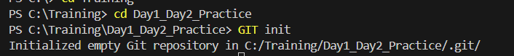

2)
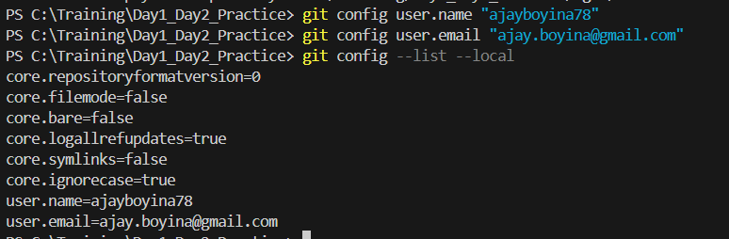

3) 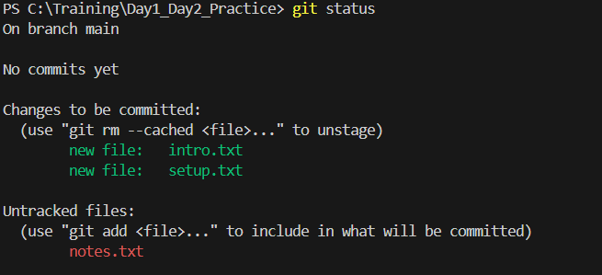

4)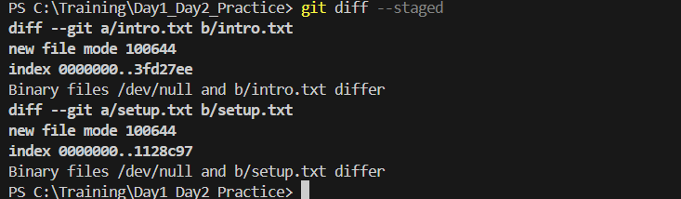

5)
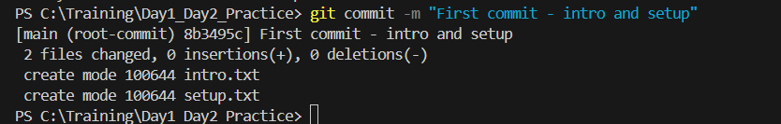

6) with this commit, Git uses the version that was staged, not the updated one. The second edit remains in working directory

7)
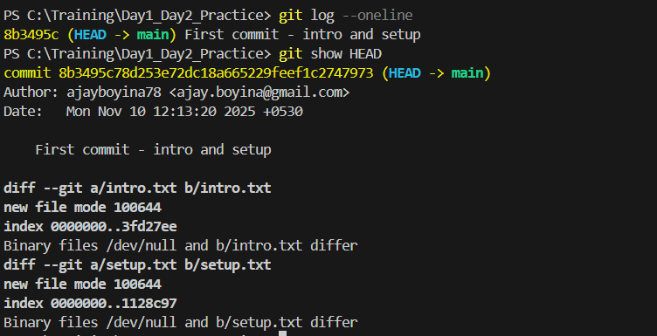

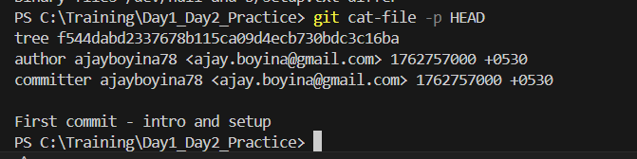

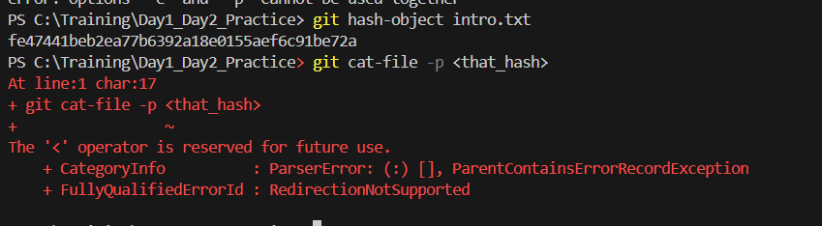

7) 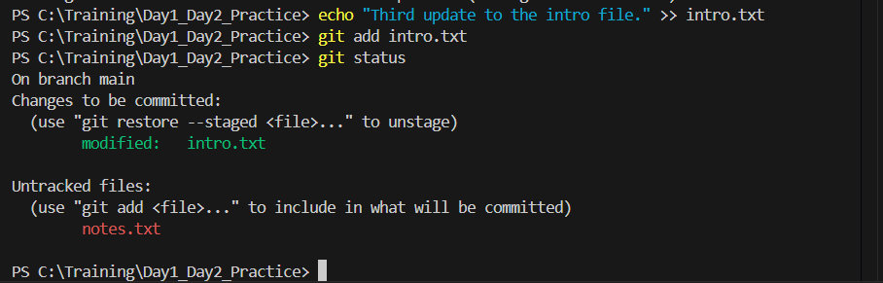

What happens inside Git when you run git add file.txt?

Git captures the current state of file.txt and stores it in the staging area

What is stored inside the .git folder?
The .git folder is what makes a directory a Git repository, It stores everything Git needs to track changes, branches, commits, and configuration.
Contains : Head, Config, Description, info, objects, Index

What does HEAD point to, and how is it updated?

Head is a special pointer that tells where are in the repository, which commit or branch working on.

What’s the difference between the Working Directory and the Staging Area?
Working directory : actual project folder on disk and contains the files , any changes happens here first
Staging Area : middle layer between working directory and repository, staged changes are included in after commit

What happens if you change a file after staging it?
The latest changes are not staged and won’t be included in the commit unless you add again

Why doesn’t Git store whole files for every commit?

What is version control, and how does Git make it easier?

Version control is a system that helps track changes to files over time, allowing multiple people to collaborate, revert to earlier versions

What are tracked vs untracked files
Tracked files : Committed or staged
Untacked files : files have not been added

Write the complete flow of commands from creating a repo to committing your first file.

GIT Init
Echo “Test” > Text.txt
Git status
Git add Text.txt
Git Commit -m “commit Text.txt”

